IFT 166 Introduction to Internet Networking
Lab 28
IP Phone Connection
Co-authored by Joshua McNair

After you complete each step, put a ‘√’ or ‘x’ in the completed box

- Set up the following topology in Packet Tracer.

Connect Phone1 to the switch with copper straight through cable.

Do not connect the second phone yet !

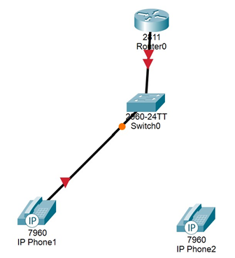



- Assign an IP address to interface fa 0/0 on the router.

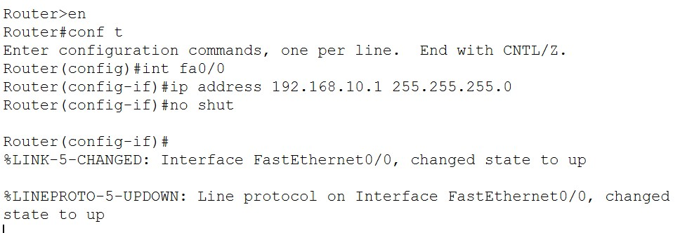

- We will need to configure a dhcp server in order to make sure that the phones have an IP address.
Option 150 is the command that we use to determine the ip address of the TFTP server which stores the configuration files for VOIP phones.

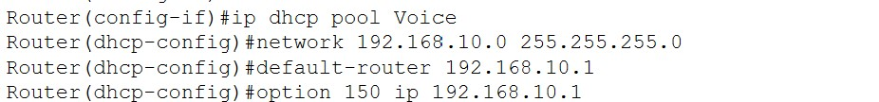

- Power on phone one by dragging the power cable (from the modules section) onto the physical interface (under the three phone ports) on the phone.

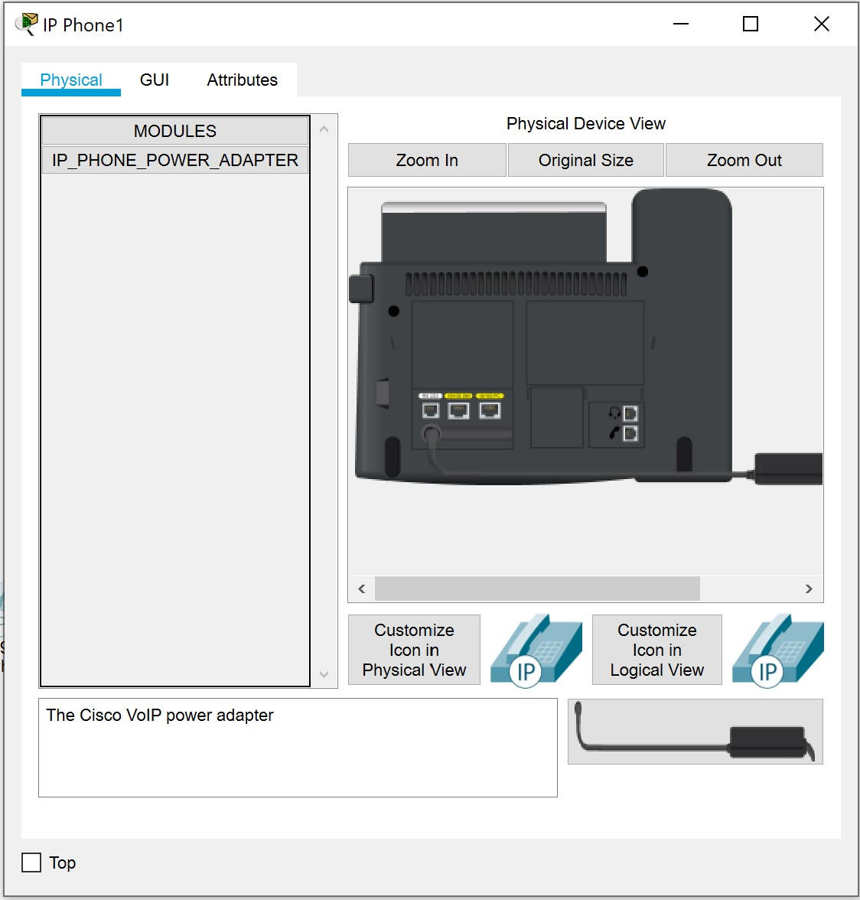

- We will now configure the Cisco Call Manager on the router.

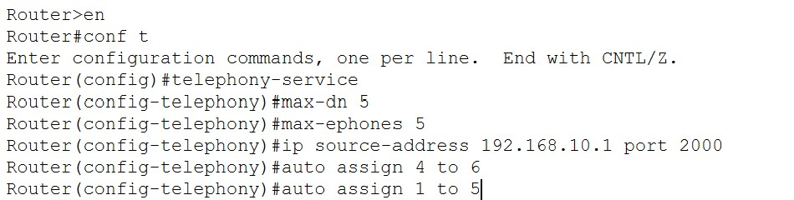

- Next, we will configure a vlan on the switch. The vlan will enable us to separate the voice data from the other data on the network.

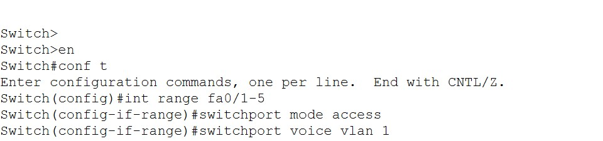

- Now we need to set up the phone for some additional configuration so that it can communicate properly.

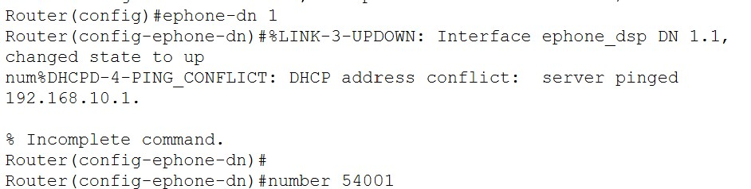

- Connect phone 2 and power it up as we did with phone 1.

- Configure the phone directory for the new phone.

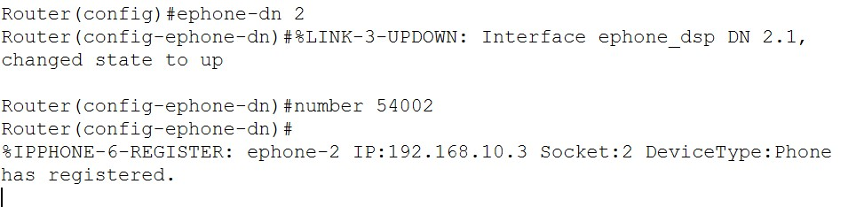

- Select the physical interface of phone 1 and dial 54002 and then hit return to make the call.

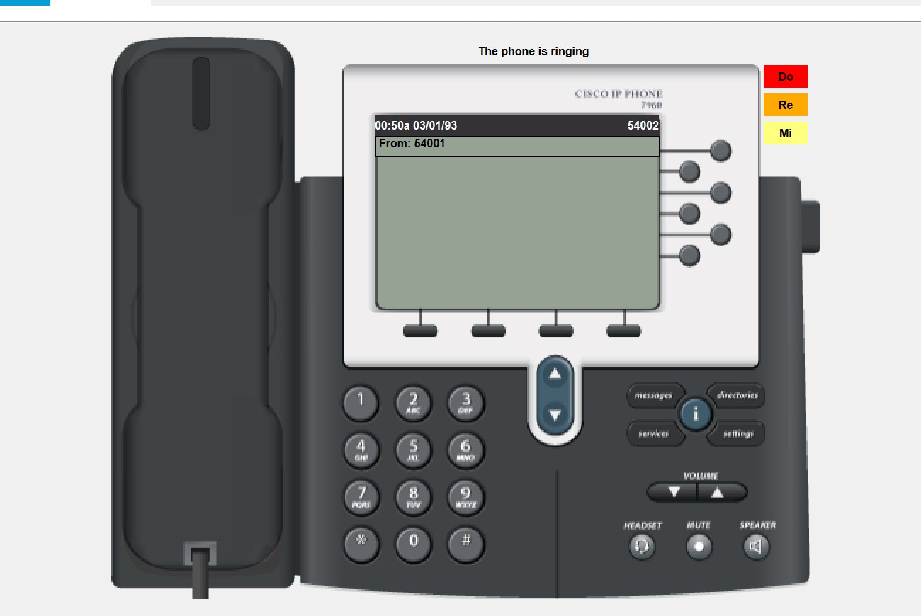

- Make sure that phone 2 received the call by clicking on phone two.

